**BY**

**EMMANUEL DURU**

**MATRIC NUMBER: 2502665**

**GROUP 3**

**TEAM 32**

**PROFESSOR WOLFGANG RENZ**

**Problem1 (A)**

**METHOD OF SOLUTION:** I was able to make to make a class of circle for the sun, instantiated it and used the method to allocate it to its position and changed the color to yellow as it is represented on the snipped document attached below, I copied the code from the SHOW TERMINAL is represented below.

Triangle triangle1 = new Triangle();

Triangle triangle2 = new Triangle();

Triangle triangle3 = new Triangle();

triangle1.makeVisible();triangle1.changeSize(40, 30);triangle1.moveUp();triangle1.moveUp();triangle1.moveUp();triangle1.moveUp();triangle1.moveUp();triangle1.moveUp();triangle2.makeVisible();triangle2.moveUp();triangle2.moveUp();triangle2.moveUp();triangle2.moveUp();triangle2.moveUp();triangle2.moveDown();triangle1.changeSize(50, 40);triangle3.makeVisible();triangle3.moveUp();triangle3.changeSize(100, 80);triangle3.changeSize(40, 90);triangle3.changeSize(70, 100);triangle3.moveUp();

Circle circle1 = new Circle();

circle1.makeVisible();

circle1.changeColor("yellow");

circle1.moveHorizontal(100);

circle1.moveVertical(50);

circle1.moveUp();

circle1.moveUp();

circle1.moveUp();

circle1.moveUp();

circle1.moveUp();

circle1.moveUp();

circle1.moveUp();

circle1.moveRight();

circle1.moveRight();

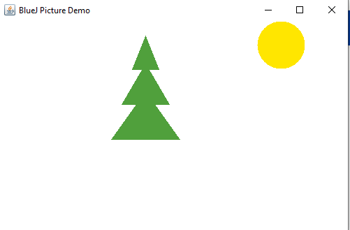

**PROBLEM 1 (B)**

**SOLUTION & REPORT:** i used the method voidslowMoveVertical(int distance) which I allocated a value of “80” to make it move down slowly the code I copied from the terminal is stated below.

**circle1.slowMoveVertical(80);**

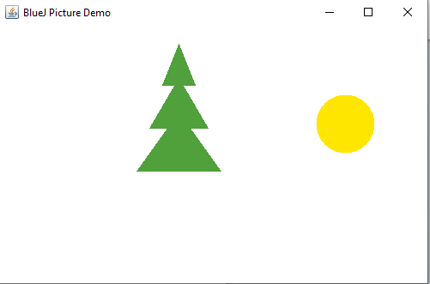

**PROBLEM 2:**

I generated the class **Animation**, I had to edit the code editor of which I had a private variable fields with the instances of the objects in my scene from problem 1A. I initialized this variable in the constructor. I also created a method “void draw()” and copied the code from problem 1A, which makes the display of the objects (fri-tree and the sun) in my project. I created a second method “void start()” which allows the sun to move vertically downwards of which the project file is been uploaded for results.

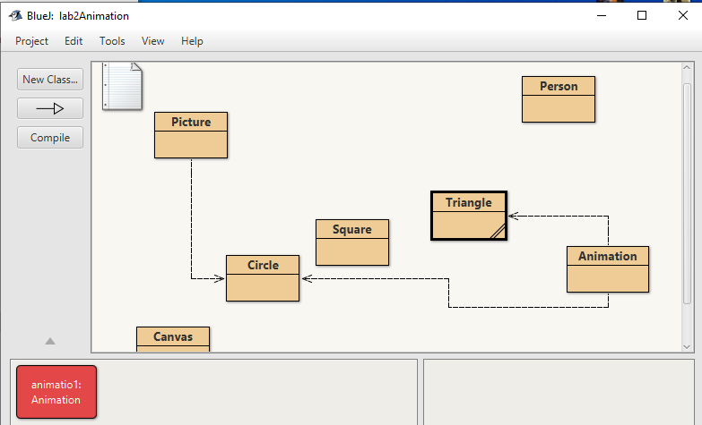

**PROBLEM 3:**

I ensured that I instantiated 4 students (my family members) of which their names is stated respectively in the record terminal given below, i got them enrolled in the lab class. I allocated the credits to each of the students and defined the instructor with a given name and room respectively. The code from the terminal is given below

**LAB ( B Family)**

Student Elizabeth = new Student("Elizabeth duru", "12032");

Student Paul = new Student("Paul duru", "1928");

Student David = new Student("David Duru", "12837");

Student Deborah = new Student("Deborah duru", "6236");

LabClass familyGroup = new LabClass(4);

Elizabeth.getLoginName()

returned String "Eliz120"

Paul.getLoginName()

returned String "Paul192"

David.getLoginName()

returned String "Davi128"

Deborah.getLoginName()

returned String "Debo623"

Elizabeth.getCredits()

returned int 0

Paul.getCredits()

returned int 0

David.getCredits()

returned int 0

Deborah.getCredits()

returned int 0

familyGroup.setRoom("222A");

familyGroup.setTime("8.10-10.25AM");

familyGroup.setInstructor("MR. Felix Duru");

familyGroup.printList();

Lab class 8.10-10.25AM

Instructor: MR. Felix Duru Room: 222A

Class list:

Number of students: 0

familyGroup.enrollStudent(Elizabeth);

familyGroup.enrollStudent(Paul);

familyGroup.enrollStudent(David);

familyGroup.enrollStudent(Deborah);

familyGroup.printList();

Lab class 8.10-10.25AM

Instructor: MR. Felix Duru Room: 222A

Class list:

Elizabeth duru, student ID: 12032, credits: 0

Paul duru, student ID: 1928, credits: 0

David Duru, student ID: 12837, credits: 0

Deborah duru, student ID: 6236, credits: 0

Number of students: 4